|  |
| --- |
| Circle Language Spec: Execution Control |

## For (conditional) in a Diagram

The concept of a conditional For statement is already covered by the article *For (conditional)*. This article only explains its expression in a diagram.

Below is an example of the diagrammatic expression of a conditional For statement.

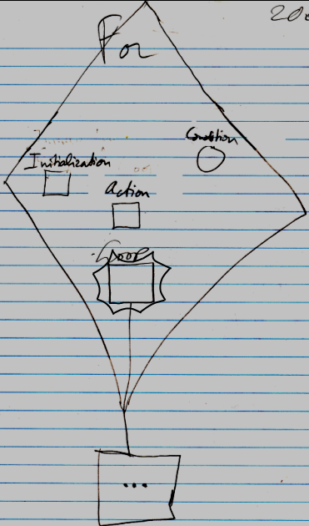

The diamond is a call to the For command. The For command will first call the Initialization procedure reference, displayed inside the diamond as a square called Initialization. The For command will then evaluate the Condition, displayed in the diamond as a circle named Condition. The Condition is a Boolean. When the Condition evaluates to True, the procedure reference Loop will be called, which is displayed inside the diamond as the square named Loop, but this square is tied to a bigger square outside the diamond, delegating the definition of the loop to outside the diamond. After execution of a loop, the Action is executed, which is visible in the diamond as a square named Action. The Action usually increments a loop variable. The loop variable is not defined in the statement. It has to be defined somewhere outside the statement. Then the Condition is evaluated again. If it is True, then the Loop procedure reference is called again. After that the Action is executed again, and the Condition is evaluated again and if it is True, the Loop procedure reference is called again. This happens over and over again, until the Condition will evaluate to False. Then the loop will stop repeating.

The Loop parameter is placed inside a nonagon purely for esteatic reasons. It is a single reference to a command, and the nonagon will never contain multiple references to commands, but it is obvious the command in it will be run multiple times. The nonagon stands for multiple, so it is put around the Loop parameter, but it will always contain a single item and you cannot add any more items to it.

In the example above, the Loop procedure reference was pointing to something outside the diamond, and the other command references were not. The other command references may as well have pointed to a command definition outside of the diamond and the Loop procedure may have been defined right inside the diamond all the same. The diagram above is just an example. The Condition could also have pointed to something outside the diamond.

The *definition* of the For execution control command is part of a system module for execution control commands. The public elements of the definition look like this:

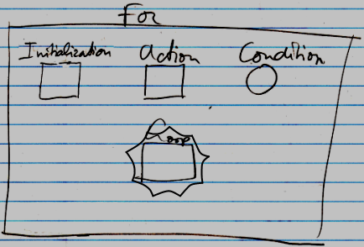

Nothing is filled in yet as the Initialization , Action , Condition or Loop .